Lab 2

Kevin Liang : kgl392

Matthew Tan : mmt2338

Nicholas Sehy : nws326

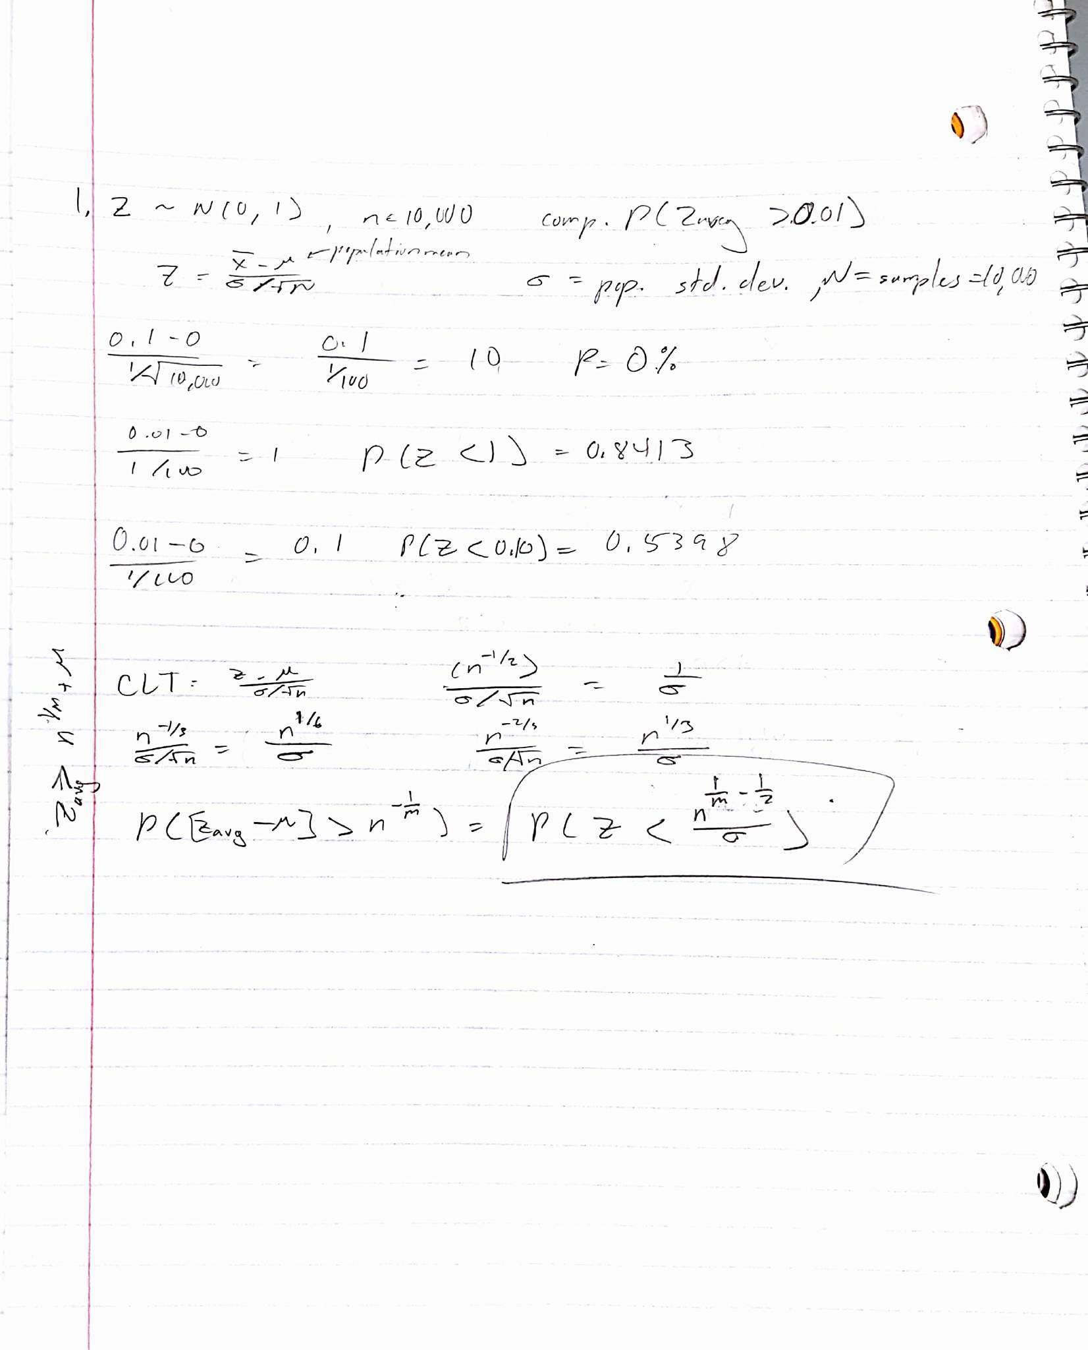

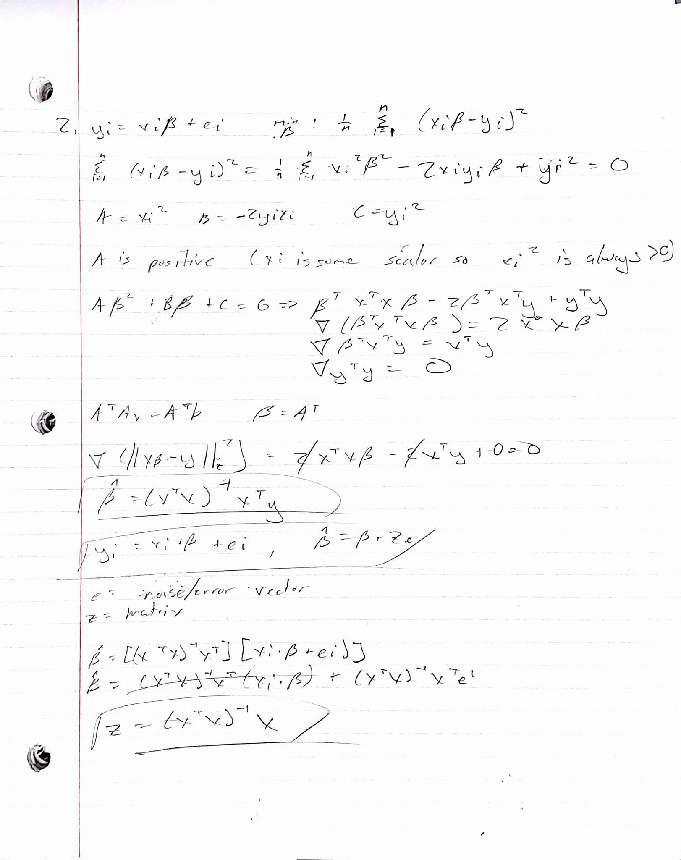

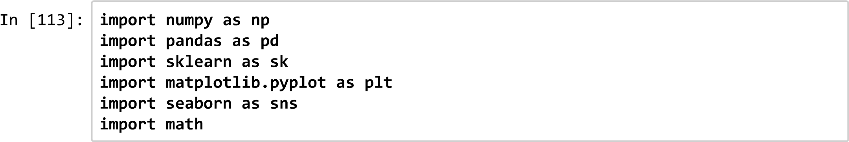

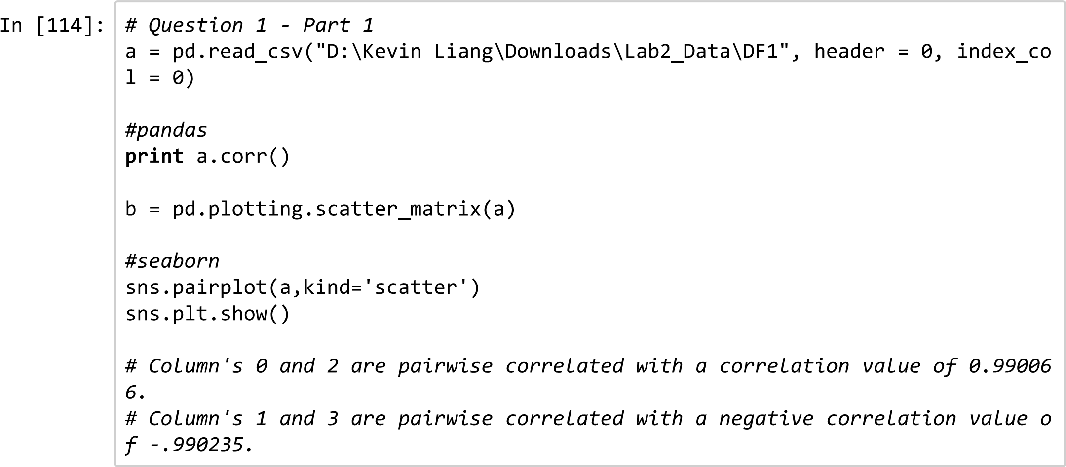

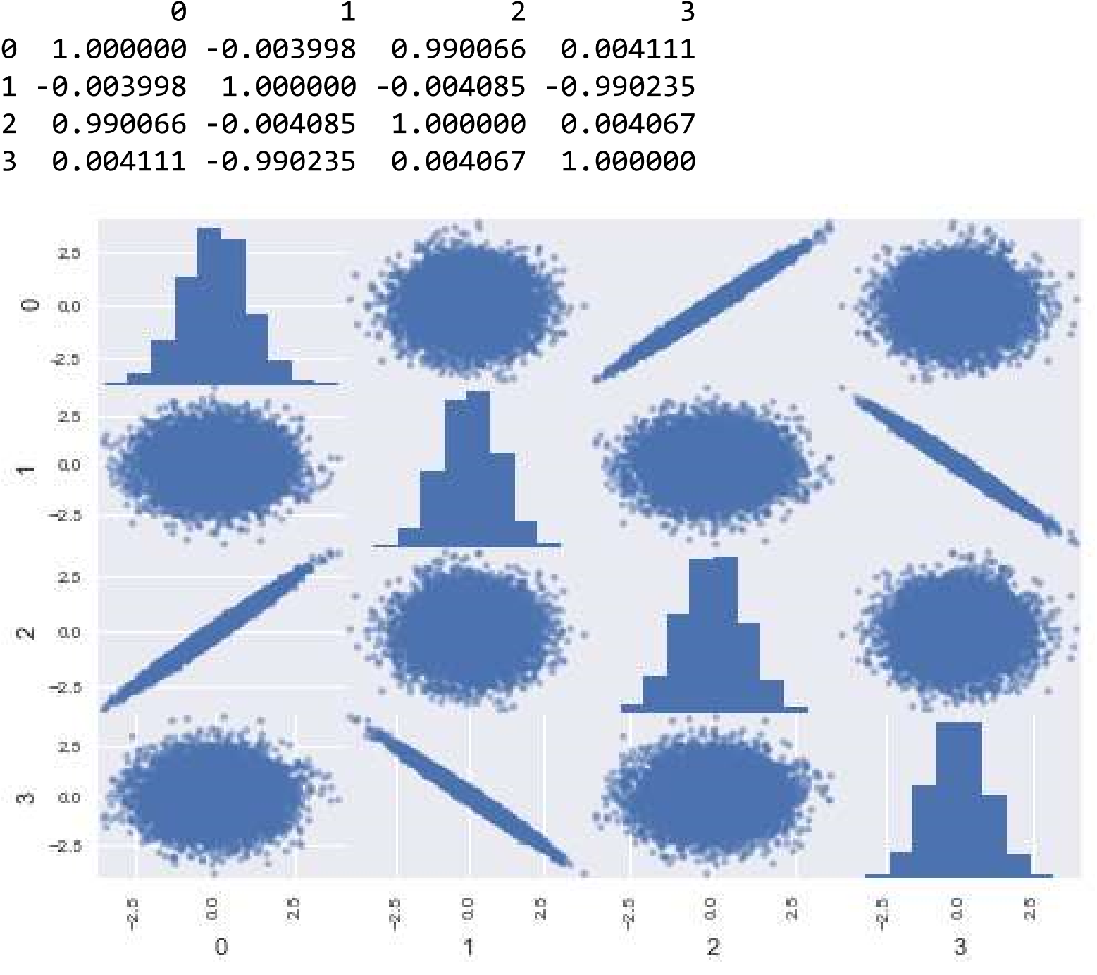

|  |  |  |  |  |
| --- | --- | --- | --- | --- |
|  |  |  |  |  |
|  |  |  |  |  |
|  |  |  |  |  |
|  |  |  |  |  |
|  |  |  |  |  |

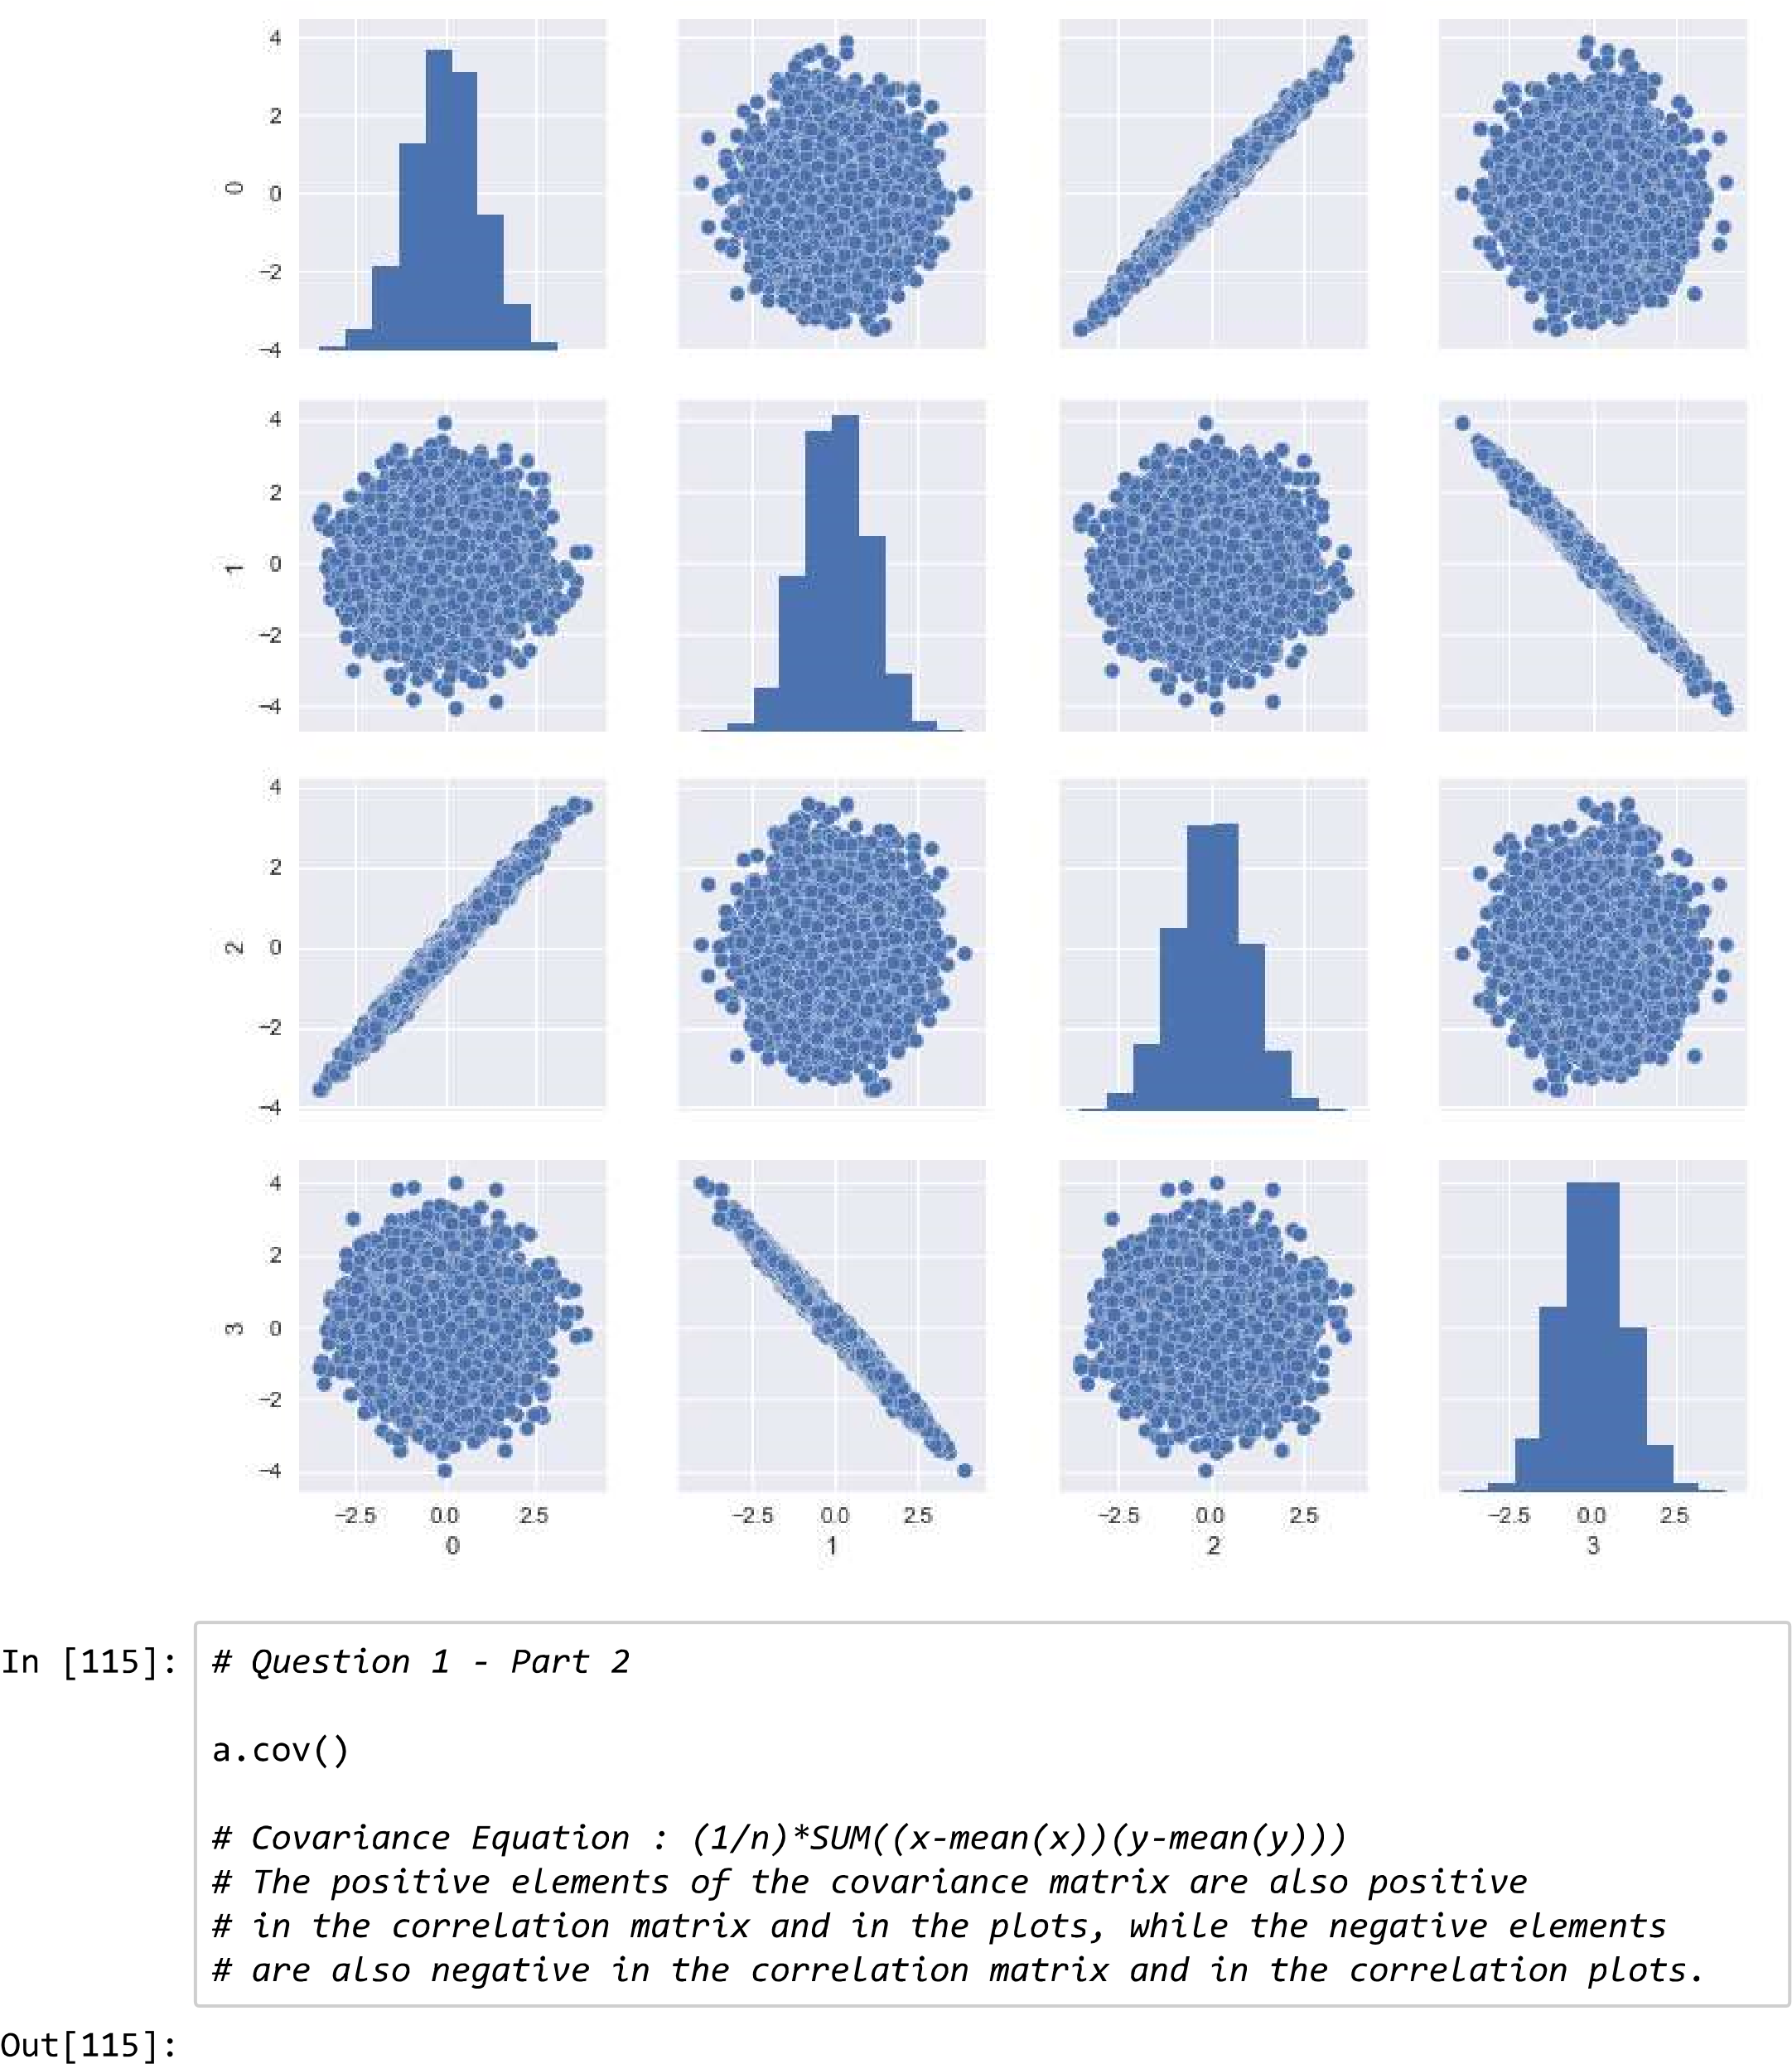

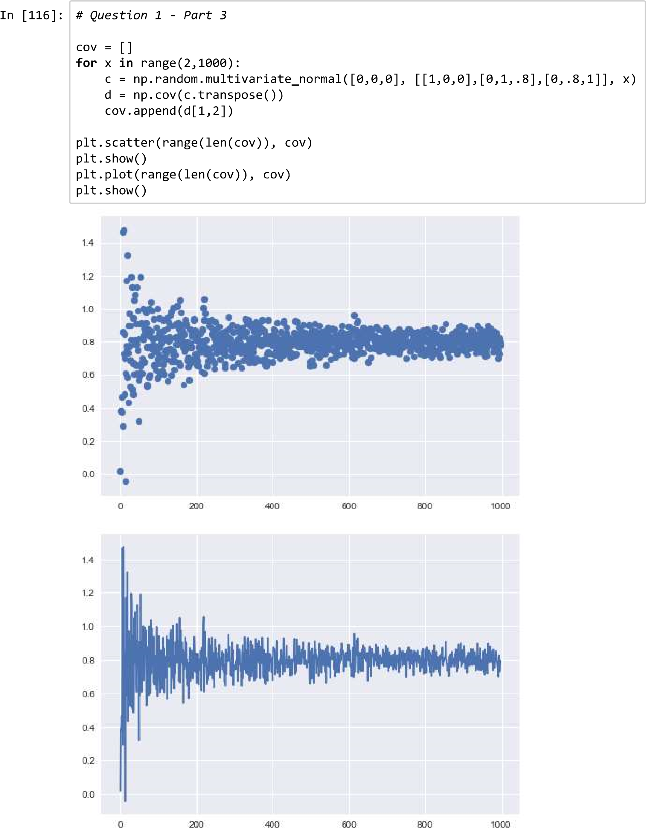

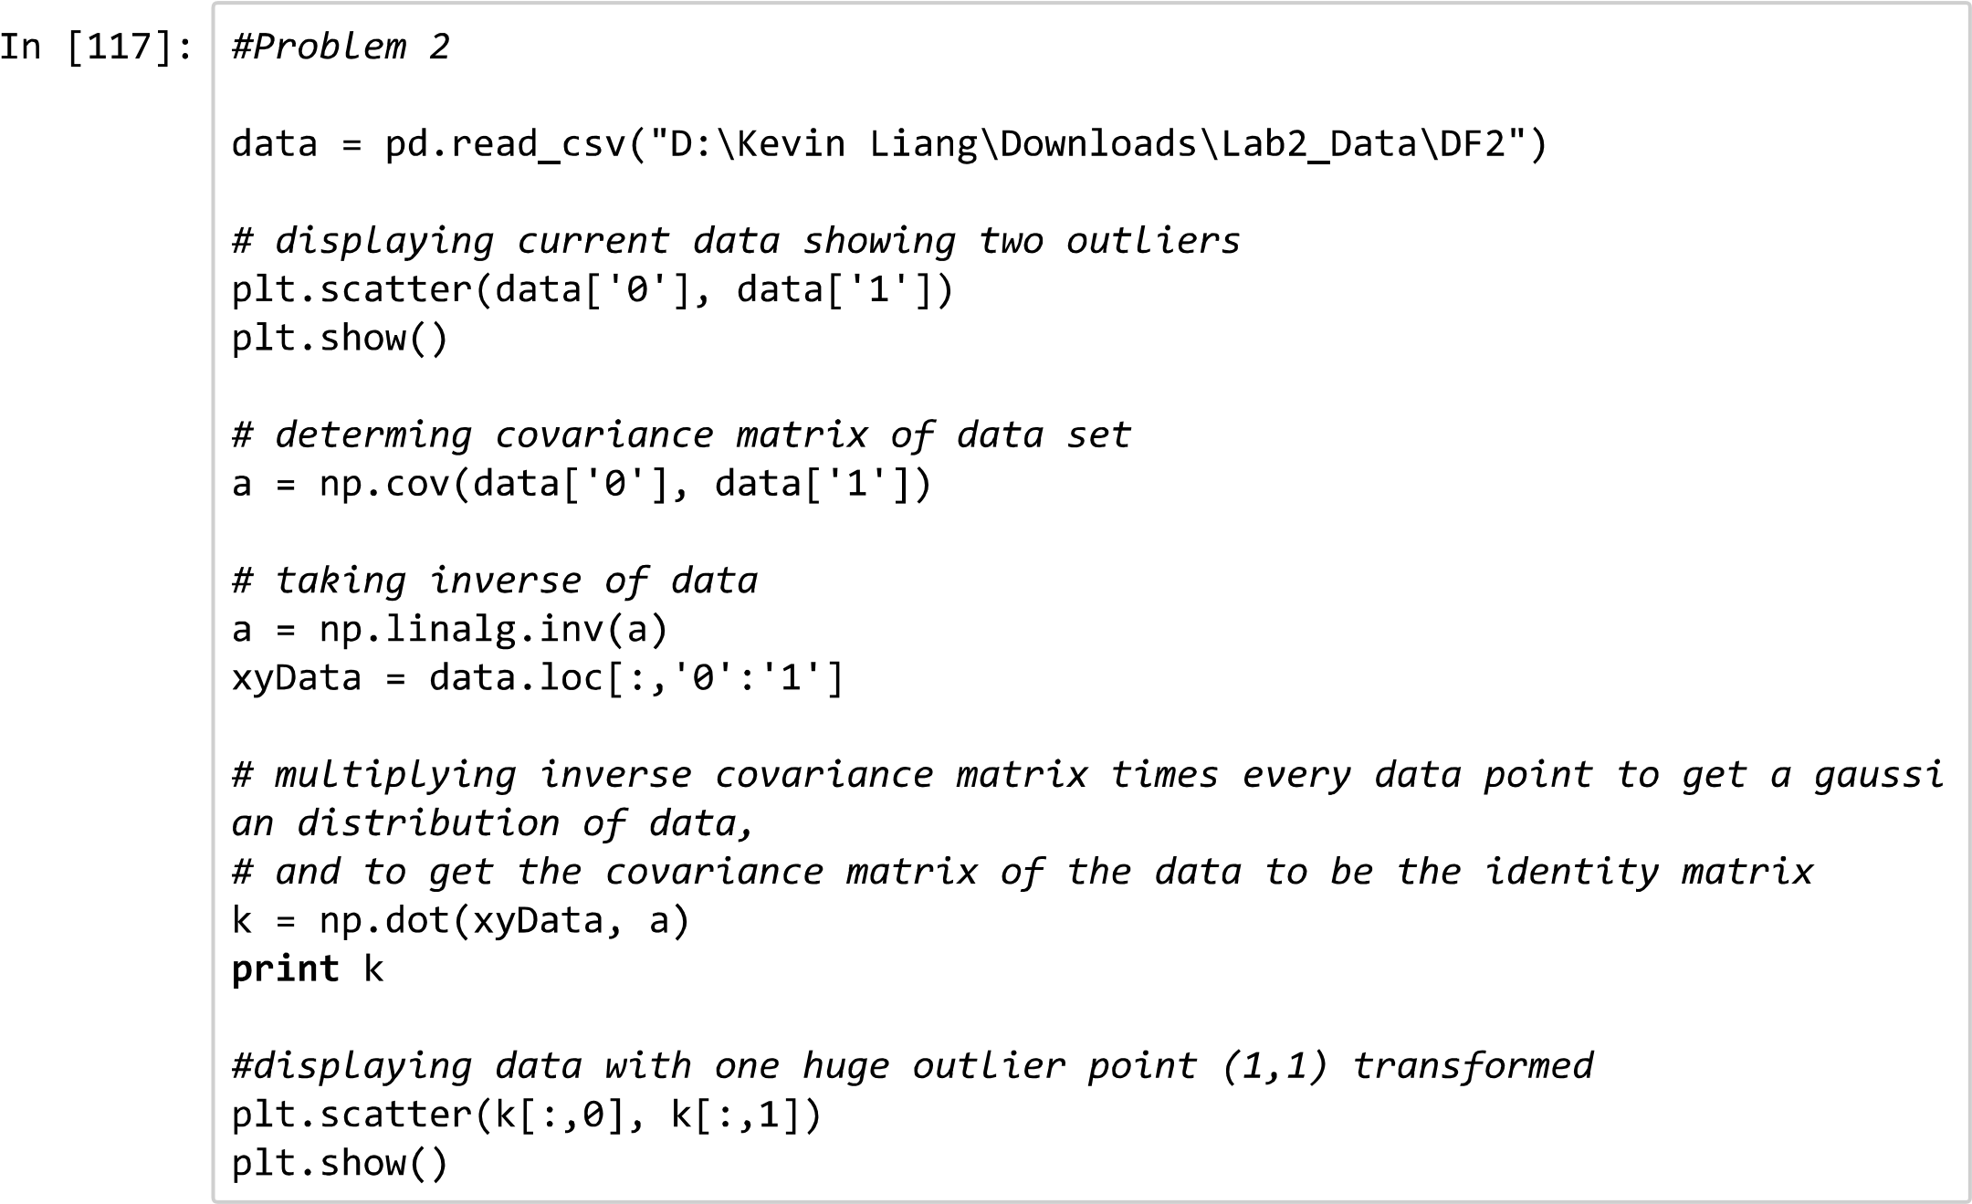

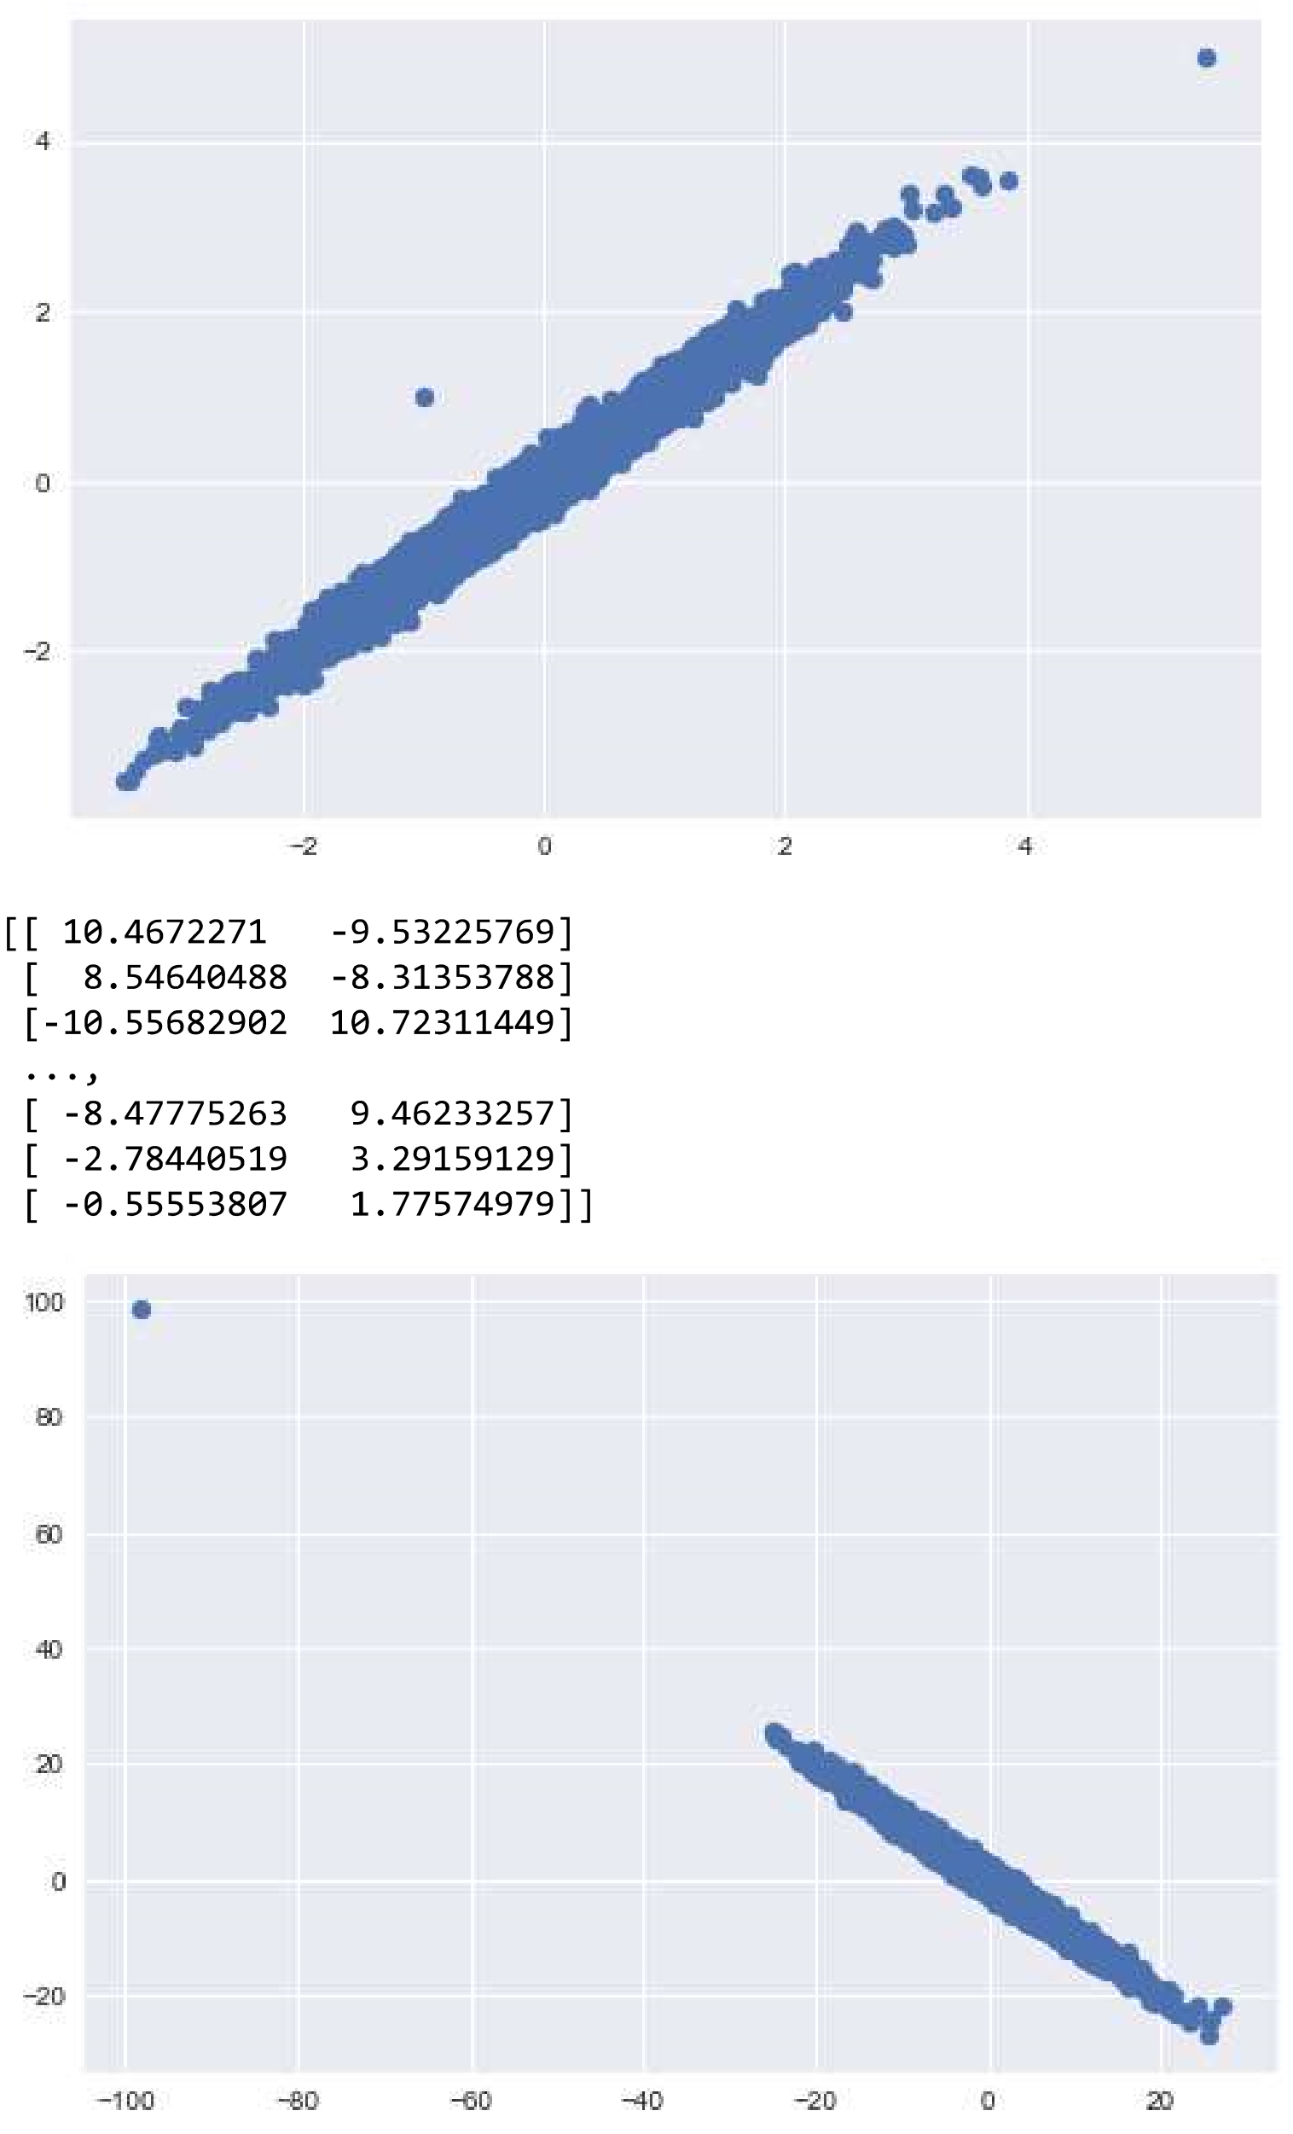

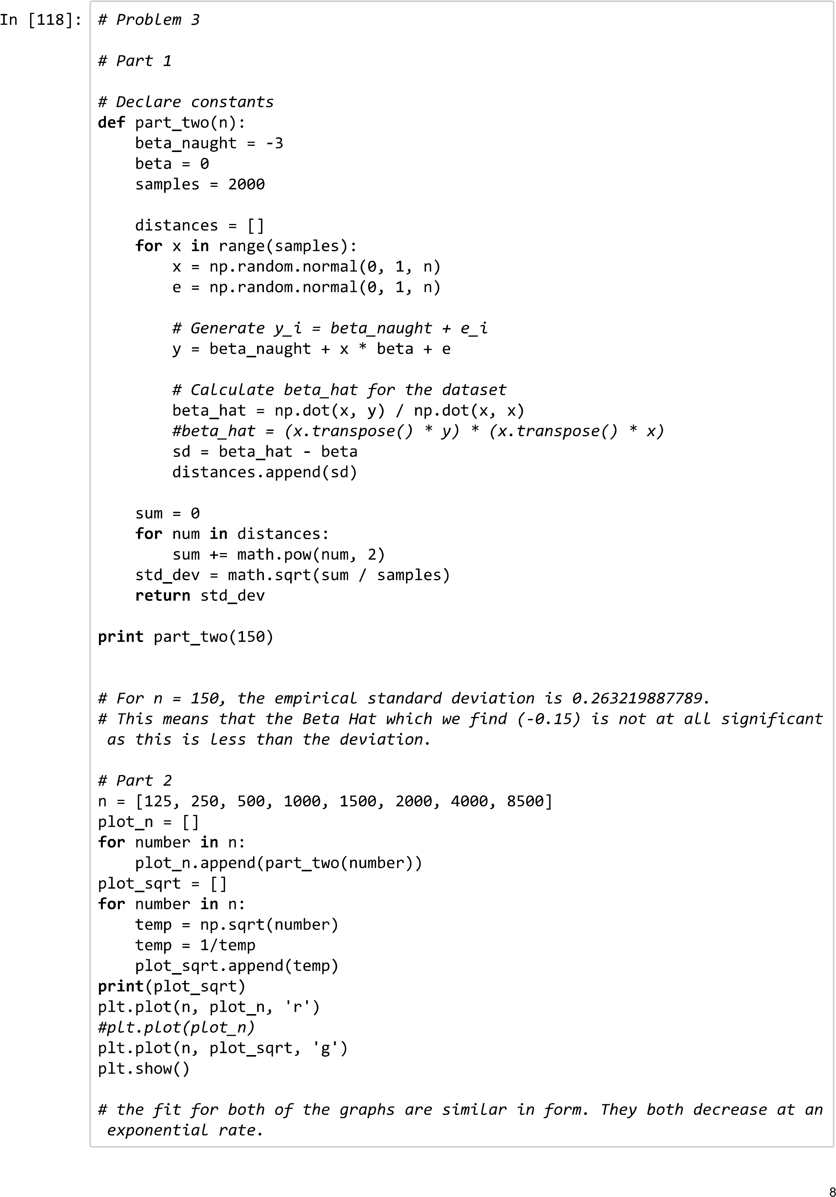

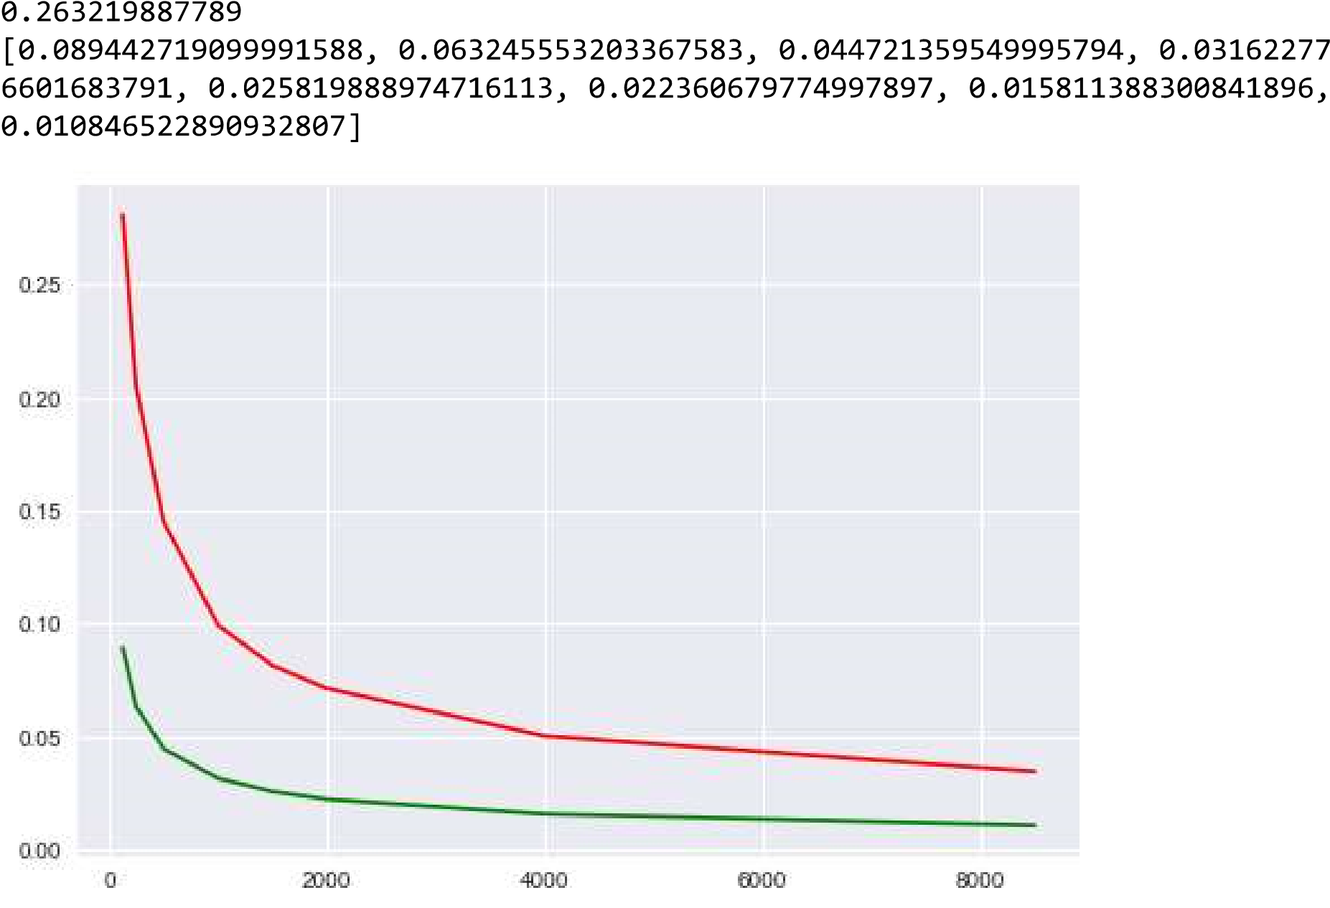

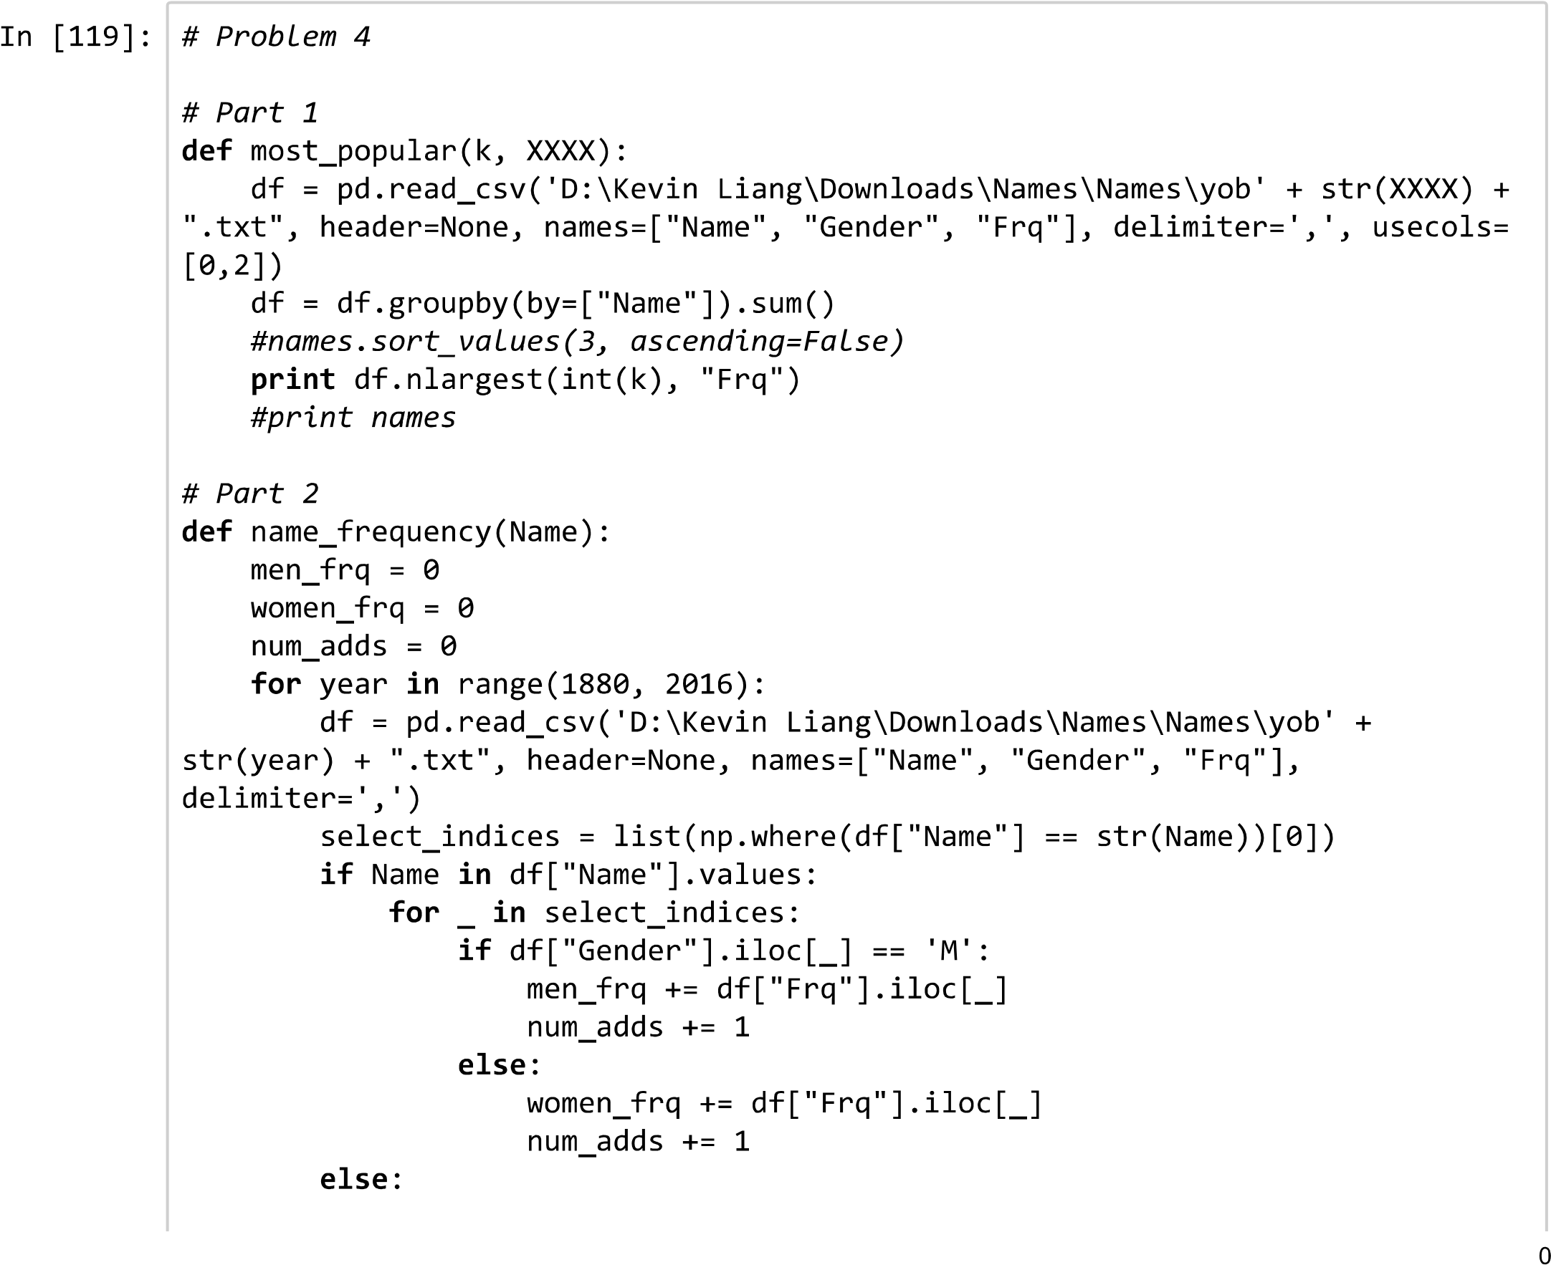

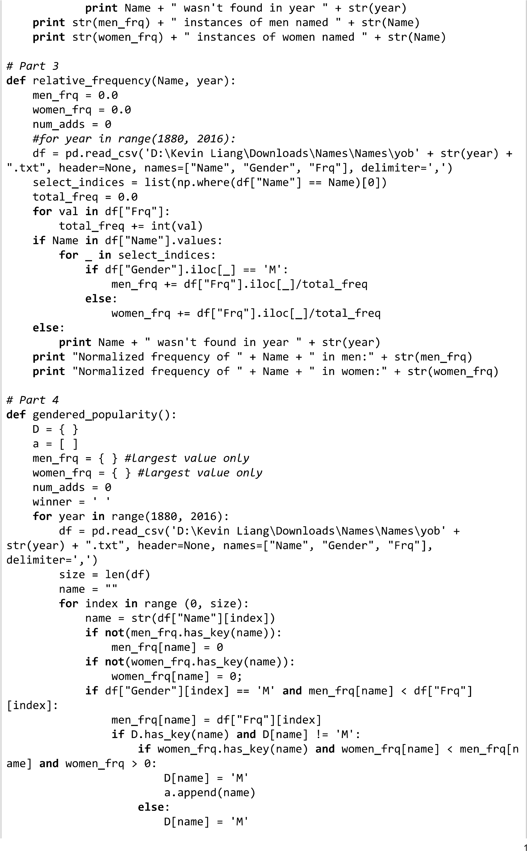

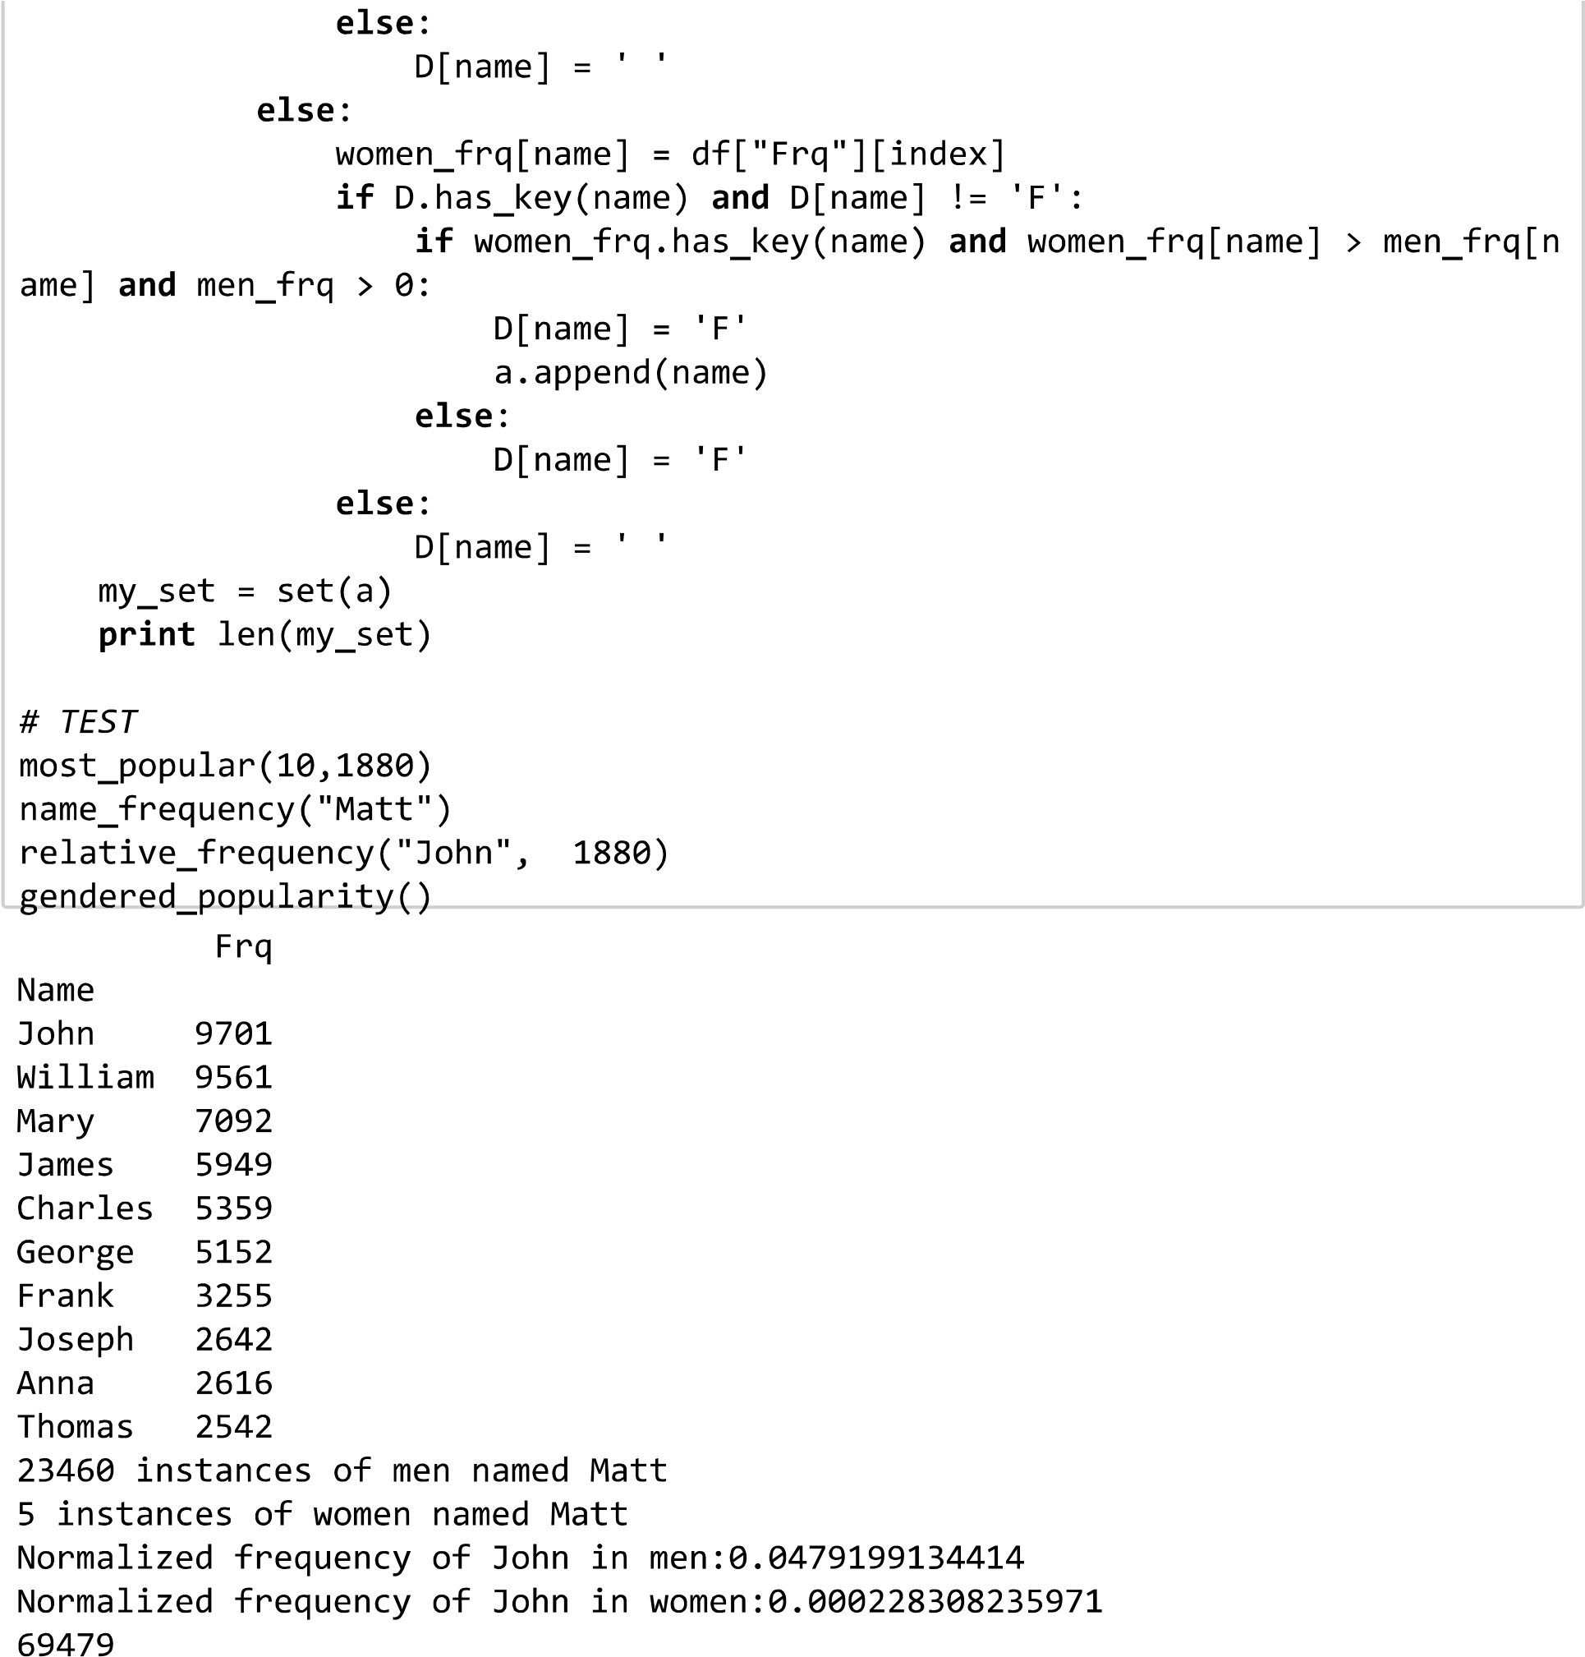

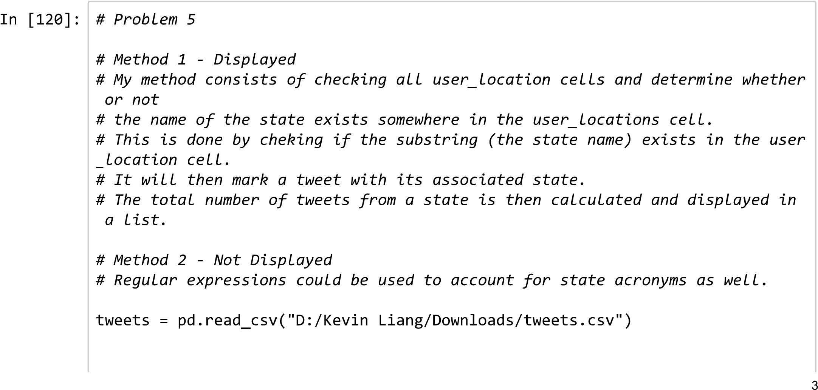

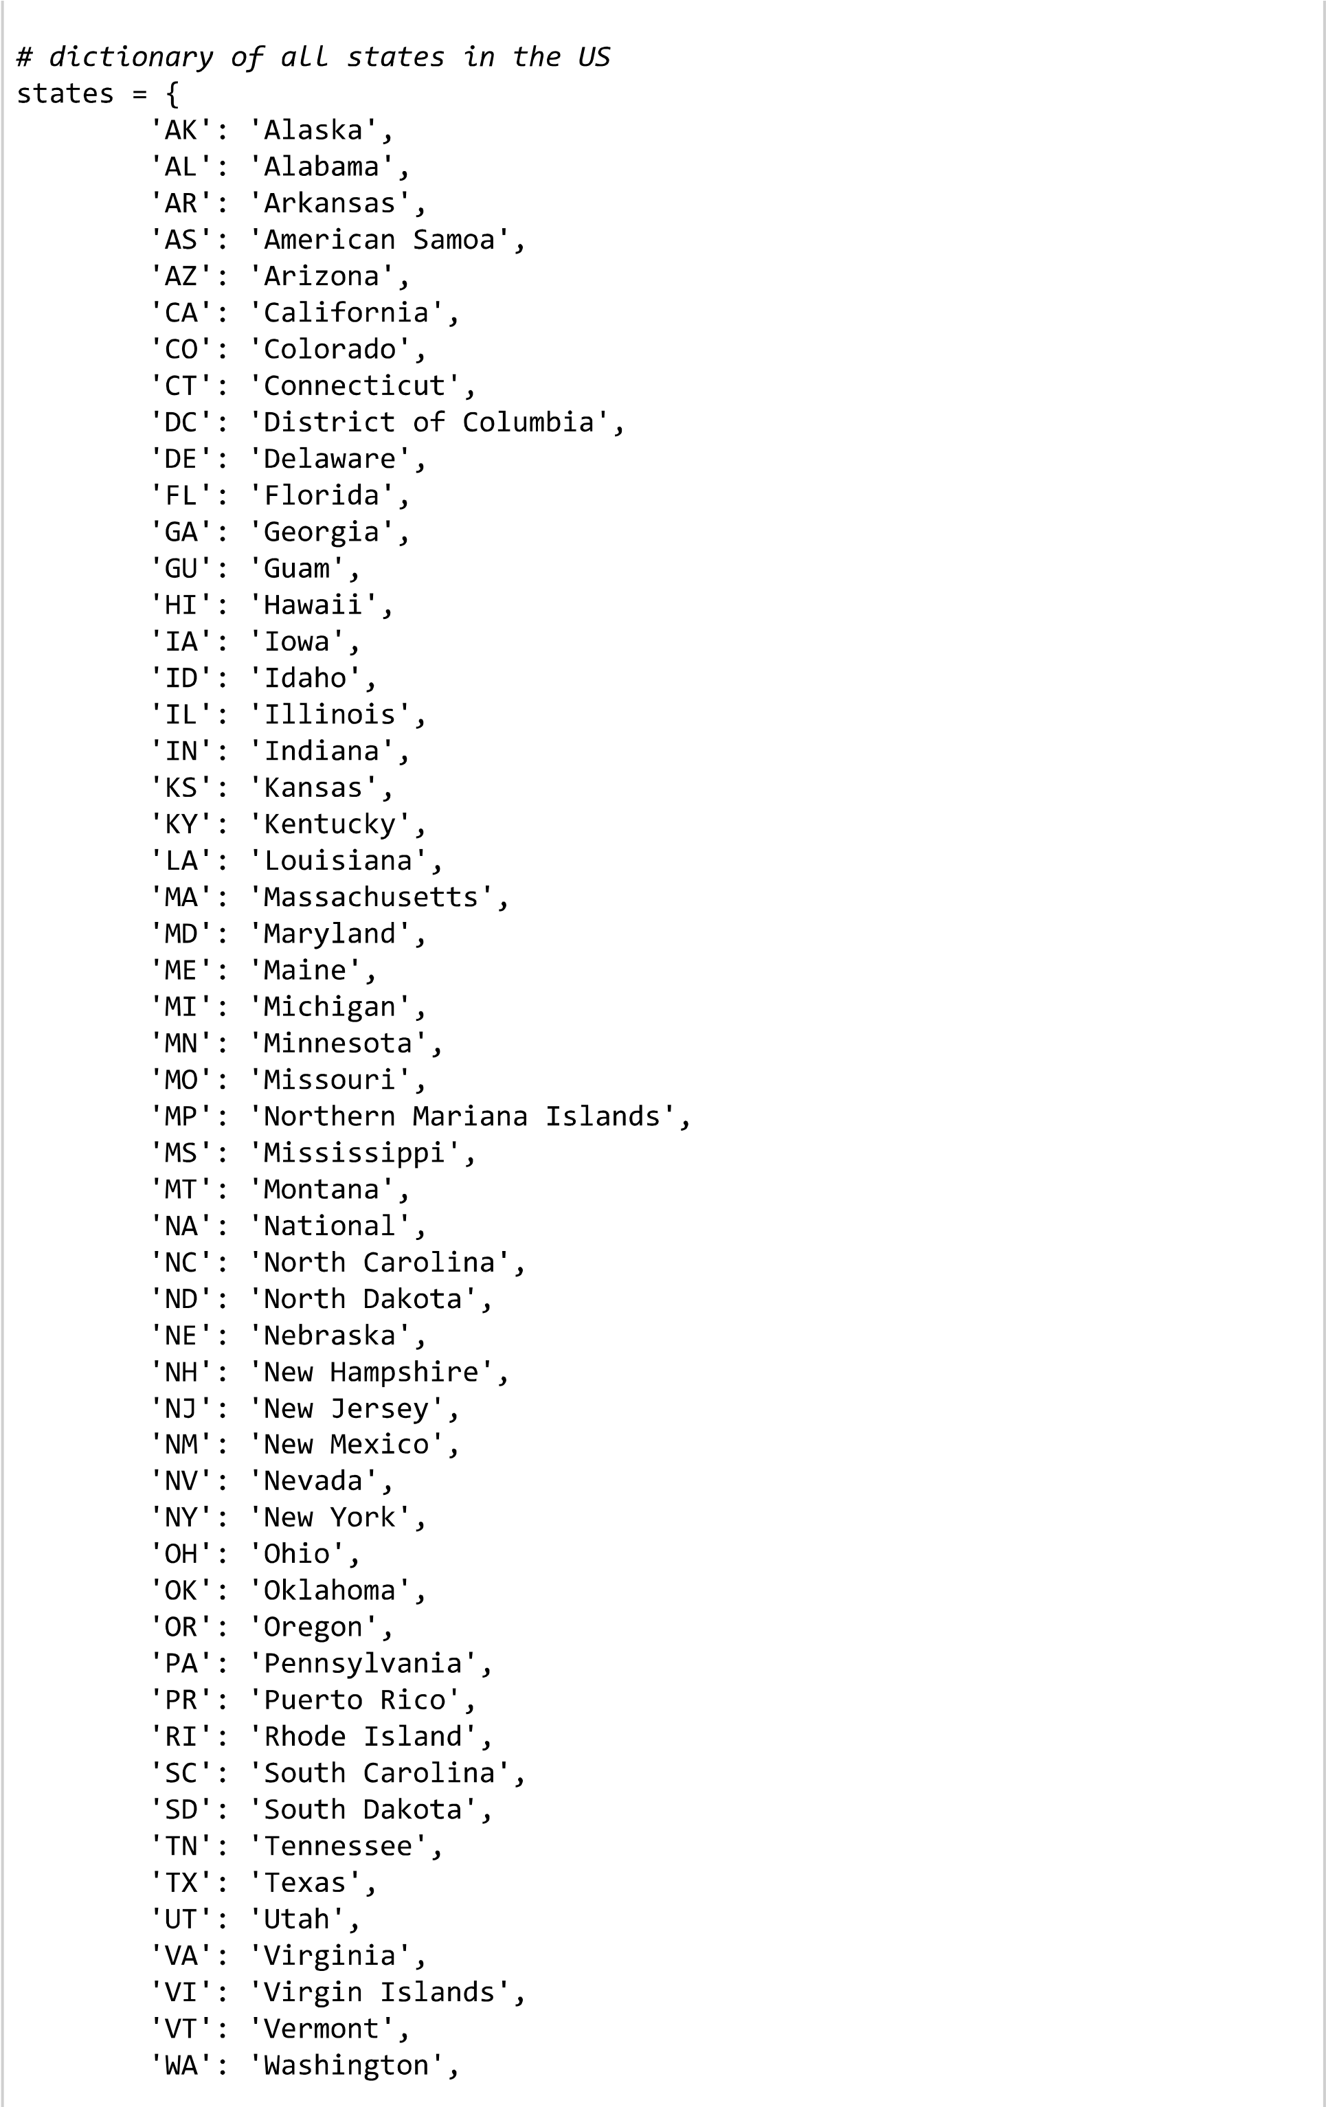

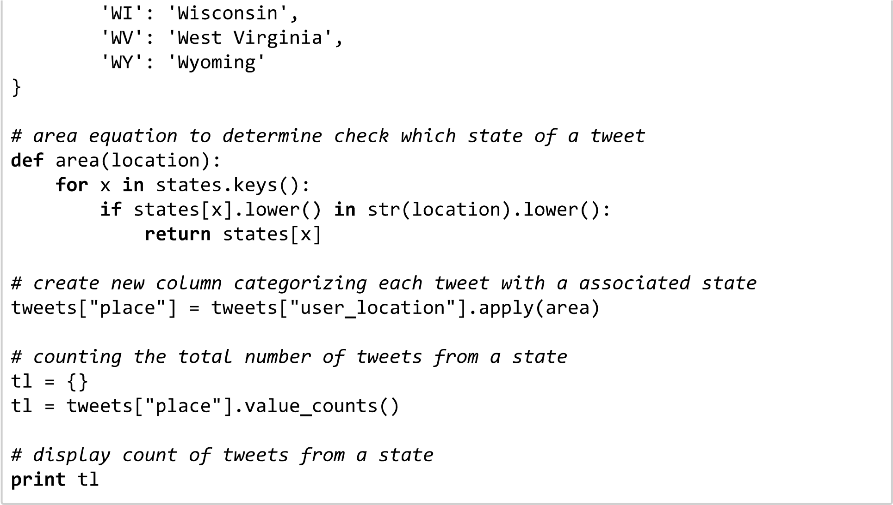

The print result isn’t showing.

Texas 4795

New York 4520

Florida 4042

California 4007

Washington 3335

Ohio 1326

New Jersey 1207

North Carolina 1138

Michigan 1138

Colorado 1070

Georgia 1031

Virginia 1008

Tennessee 990

Arizona 986

Indiana 910

Pennsylvania 890

Oregon 822

Kansas 734

Illinois 713

Maryland 579

Alabama 572

South Carolina 559

Massachusetts 521

Wisconsin 514

Minnesota 509

Oklahoma 504

Louisiana 486

Missouri 462

Iowa 447

Kentucky 397

Connecticut 367

Nevada 312

Maine 258

West Virginia 249

Hawaii 247

Vermont 242

New Hampshire 238

Utah 211

Delaware 199

Montana 176

Alaska 173

National 172

Idaho 158

Mississippi 153

New Mexico 151

Nebraska 145

Rhode Island 120

Puerto Rico 113

Wyoming 55

Virgin Islands 36

North Dakota 26

District of Columbia 25

South Dakota 24

Guam 7

American Samoa 1

Name: place, dtype: int64